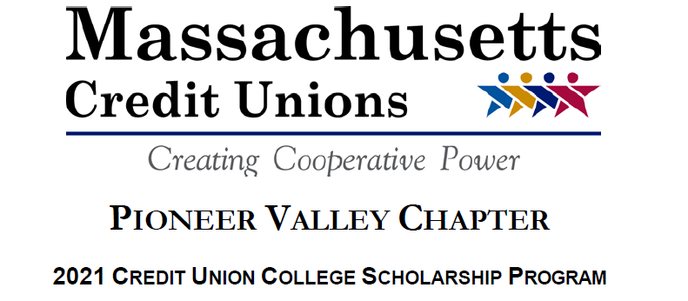

A division of the Cooperative Credit Union Association

The Pioneer Valley Chapter’s Scholarship Committee will be awarding eight (8) $2,000 Chapter Scholarships and one (1) $1,500 Cooperative Credit Union League Scholarship. Information regarding eligibility for these scholarships is listed below.

- Eligibility is limited to high school seniors who will be enrolled in an undergraduate college degree program during the 20121-2022 academic years.

- Applicant or parent/guardian must be a member of Holyoke Credit Union (the sponsoring credit union).

- Each applicant must complete a current 2021 Scholarship Application form and submit it with the other required material to Holyoke Credit Union (the sponsoring credit union).

The Scholarship Committee will select the scholarship winners evaluating each applicant on the following criteria: academic achievement, extracurricular/community activities and essay.

Students must submit the following items with their completed applications. All items requested must be received in order for the application to qualify for consideration.

- Completed application.

- List of extracurricular school activities and community service.

- Students must submit a typewritten essay in 500 words or less on the following topic: “The pandemic has challenged and influenced everyone in some way. What surprised you most on how it personally impacted you, and how you adapted?”
- An official high school academic transcript of grades, including midyear/first semester senior grades, completed by their counselor.

- Standardized (SAT, ACT or both) testing scores (either on official high school transcript or a copy from a testing agency).

Deadline: All Pioneer Valley Chapter Scholarship applications from Holyoke Credit Union Members must be submitted to Barbara Baran, c/o Holyoke Credit Union, 490 Westfield Road, Holyoke, MA 01040 by Friday, March 12, 2021.

If you have any questions about the 2021 Pioneer Valley Chapter/League College Scholarship Program, please contact Barbara Baran, Executive Administrative Assistant, at 413-278-6833 or at bbaran@holyokecu.com.

